GUJARAT TECHNOLOGICAL UNIVERSITY


Chandkheda, Ahmedabad
Affiliated

C. K. Pithawalla College of Engineering and Technology, Surat
A
Project Report
On

Mental Health Monitoring

Prepared as a part of the requirements for the subject of
DESIGN ENGINEERING – II B (3160001)
B. E. III, Semester – VI
(Computer Engineering)
Submitted by:
Sr. No. | Name of Student | Enrollment No
1 | Jhanvi Vakharia | 230090107232
2 | Anushka Karwa | 230090107004
3 | Riya Shah | 230090107191

Prof. Chaitali V. Sheth
(Faculty Guide)

Dr Vishruti V Desai
HOD
Academic year (2025-26)
Table of Contents

ACKNOWLEDGMENT 2
ABSTRACT 3
1. Introduction 1
2. Canvases 3
AEIOU 3
Mind Mapping 7
Empathy Mapping Canvas: 8
Ideation 11
Product Development 14
3. Feedback Analysis 20
4. Prior Art Search 21
5. Functional Prototype 23
5.1 Login Page 23
5.2: Sign Up Page 24
5.3: Mood Tracker 24
5.4: Journal 25
5.5: Meditation 26
5.6: Therapy Management 27
5.7: Dashboard 28
5.8: Profile 29
6. System Architecture, Technology Stack & Database Design 31
6.1 Technology Stack 31
6.2 System Architecture 31
6.3 Database Design 31
7. Semester VI Enhancements 33
7.1 Frontend improvements 33
7.2 Backend integration 33
7.3 New features: analytics, personalization, and gamification 34
8. Summary 35
7. References 36

ACKNOWLEDGMENT

We take this opportunity to express our heartfelt gratitude to everyone who contributed to the
development of this Mental Health Monitoring application as part of our Design Engineering
project. This project would not have been possible without the guidance and support of our
mentor, Prof. Chaitali Sheth, whose valuable insights and expertise helped shape this
endeavour.

We are deeply appreciative of the assistance and resources provided by C.K. Pithawala
College of Engineering and Technology, which enabled us to gain a deeper understanding of
mental health challenges and the importance of timely intervention. We are especially
grateful to the mental health professionals and institutions, including the staff at Smimer
Hospital & Medical College, and Psychiatrist Dr Mayank Agarwal, who offered their
expertise and allowed us to gain first-hand insights through conversations and observations.

Lastly, we would like to thank our head of department Dr. Vishruti Desai for the
encouragement and motivation throughout this journey. This project is dedicated to everyone
who strives to prioritize mental health and well-being.

ABSTRACT

- In today’s fast-paced world, mental well-being is often overlooked, leading to unaddressed stress, anxiety, and other mental health challenges. This project introduces a proactive application designed to address this growing concern by fostering a culture of mental health awareness and self-care. Through adaptive surveillance techniques, personalized assessment tools, and a responsive tracking system, the app empowers users to actively monitor their mental health and recognize early signs of distress. With timely interventions and data-driven insights, the platform supports individuals in maintaining mental resilience and offers practical, accessible resources for a supportive mental health journey.

Introduction

Introduction to Domain:

In the context of our Mental Health Monitoring app, Design Thinking was instrumental in identifying specific mental health challenges faced by users who may be unaware or reluctant to acknowledge their mental well-being.

By empathizing with users through research and real-world observations, we identified the need for a proactive yet supportive digital tool that makes mental health care more accessible and approachable.

This project applies each stage of Design Thinking, from defining mental health monitoring challenges to testing user-friendly features that encourage engagement without overwhelming the user.

Its importance, Socio-economical relevance
Design Thinking is significant because it fosters innovation in creating solutions that are empathetic, relevant, and practical. From a socio-economic perspective, mental health has a profound impact on productivity, healthcare costs, and overall quality of life. Ignoring mental well-being can lead to serious socio-economic issues, including increased healthcare expenditure and reduced workplace productivity.

For our project, the Mental Health Monitoring app addresses these issues by encouraging early mental health intervention and supporting ongoing self-care. It helps lower barriers to mental health care, especially for individuals who may not seek traditional therapy due to financial constraints, social stigma, or lack of awareness. By providing a digital platform for tracking and addressing mental well-being, the app has potential socio-economic benefits, such as reducing the cost of mental health treatment and supporting a healthier, more productive community.

Learning Tools and its importance
Learning tools, including digital platforms, assessment software, and data analysis tools, are essential in understanding complex issues like mental health and applying technical solutions effectively. These tools provide insights into user behaviour, needs, and responses, enabling developers to refine features that resonate with users.

In this project, we utilized various learning tools to gather and analyse data related to mental health trends and user interactions. For example, observation tools allowed us to understand user needs and mental health triggers, while data analytics helped us design personalized assessments. The importance of these tools lies in their ability to make mental health metrics accessible, relatable, and actionable for users, empowering them to track their well-being effectively.

Team building and Log book exercises and importance
Effective team building is crucial in collaborative projects, especially in fields like Design Engineering, where each team member’s input adds unique value. Teamwork promotes idea-sharing, problem-solving, and diverse perspectives, enhancing project outcomes. Maintaining a log book is equally important, as it documents progress, records, and ideas, and allows for continuous reflection and improvement.

For our Mental Health Monitoring app, team-building exercises helped us brainstorm and refine our approach to understanding mental health concerns and designing solutions that resonate with users. Each team member’s unique perspective on mental health enriched our project, adding depth to our assessment tools and app features. Keeping a log book enabled us to document our insights from site visits, and conversations with mental health professionals, providing a structured path for project evaluation and continuous improvement.

Canvases

2.1 AEIOU

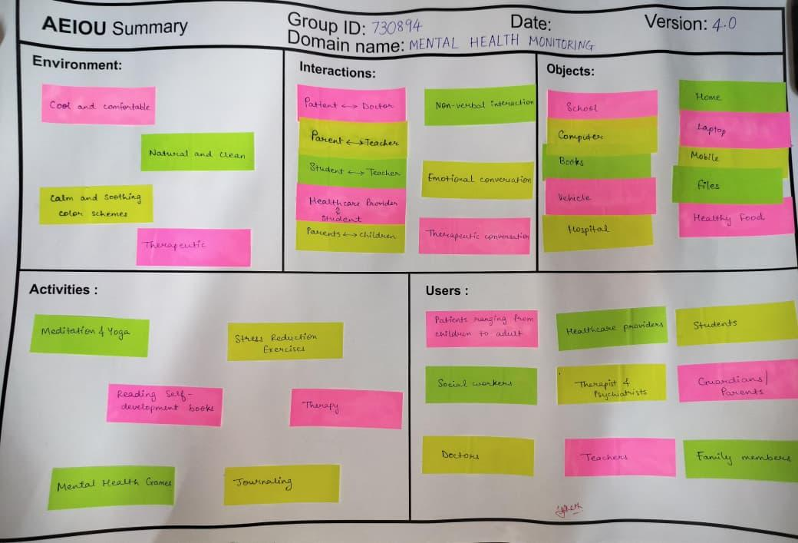
Fig 2.2.1 AEIOU
AEIOU stands for “Activities Environment Interaction Object User”.
In AEIOU canvas, there were five phases – Activities, Environment, Interaction, Object and User. Therefore, we passed all phases and one by one checked and noted down all the information of each phase. All phases are described below.

Environment:
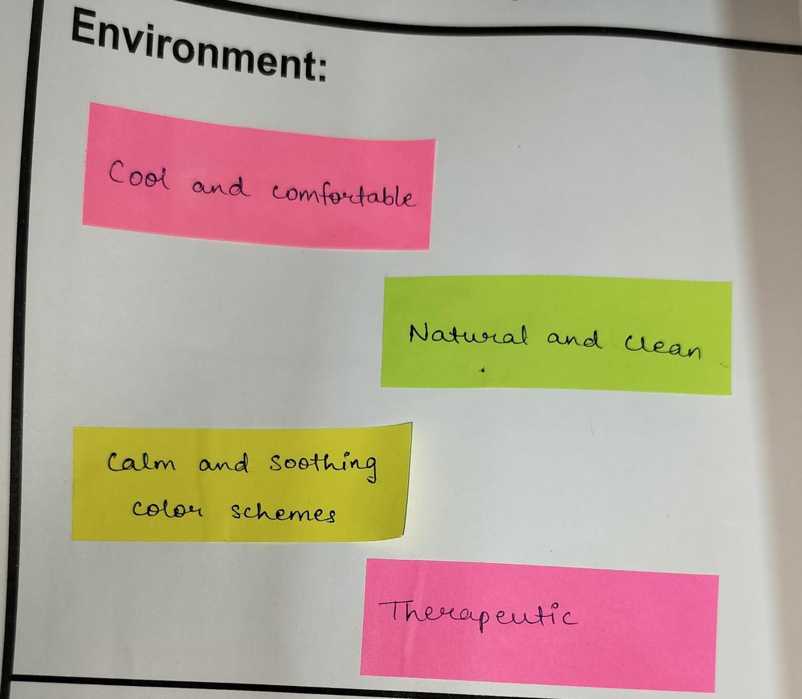
Fig 2.2.1.1 Environment
We aim to create the following environment:
- Cool and Comfortable
- Natural and Clean
- Calm and soothing colour schemes
- Therapeutic

Interactions:

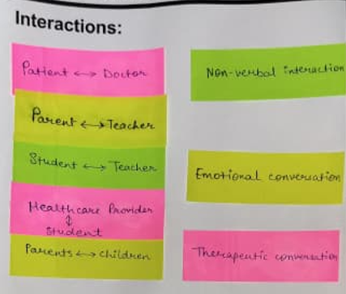
Fig 2.2.1.2 Interactions

During the survey, we had observed the following types of interactions:
- Non-verbal
- Emotional
- Therapeutic
During the survey, we had observed the interactions between the following people:
- Patients Doctor
- Parents Teacher
- Student Teacher
- Healthcare Provider Student
- Parents Children

Objects:
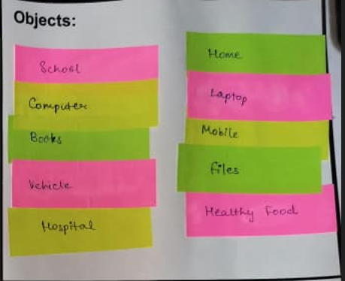
Fig 2.2.1.3 Objects
During the survey, we had found the following objects:
- School
- Computer
- Books
- Vehicle
- Hospital
- Home
- Laptop
- Mobile
- Files
- Healthy Food

Activities:
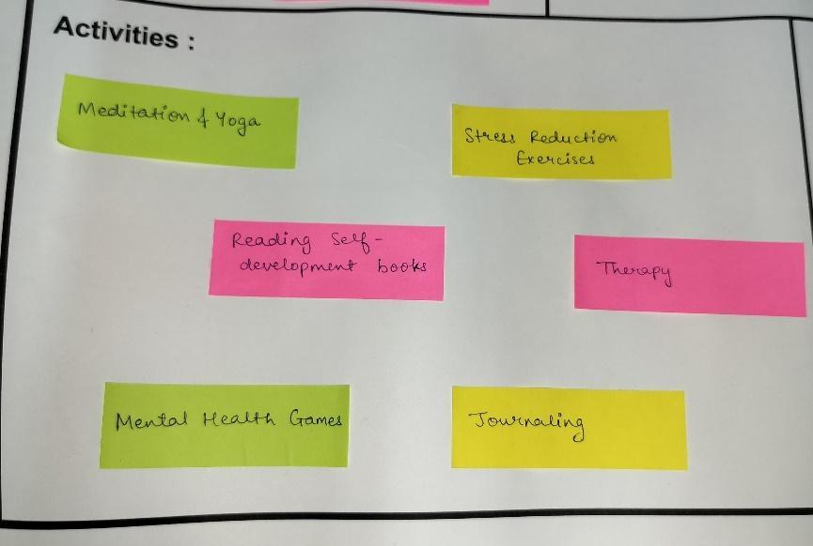
Fig 2.2.1.4 Activities
During the survey, we had observed the following activities:
- Meditation and Yoga
- Stress Reduction Exercises
- Reading self-development books
- Therapy
- Mental Health games
- Journaling

Users:
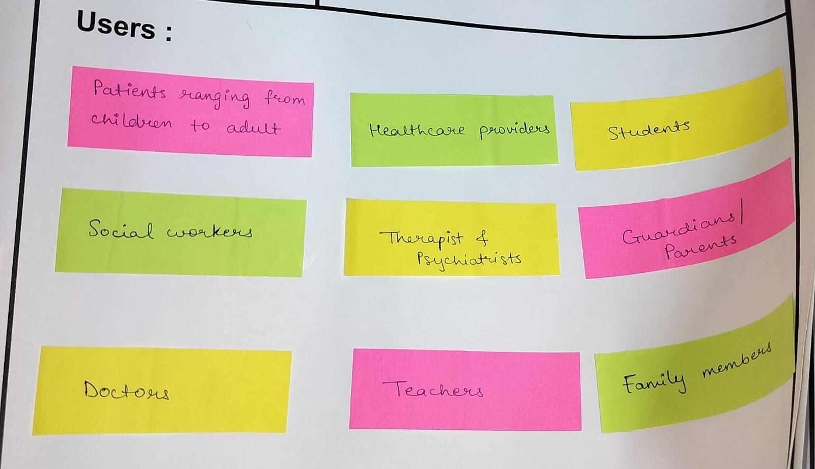
Fig 2.2.1.5 Users
People who are found at the sites we visited:
- Patients ranging from children to adults
- Healthcare Providers
- Student
- Social Workers
- Therapists and Psychiatrists
- Parents / Guardians
- Doctors
- Teachers
- Family Members

Mind Mapping
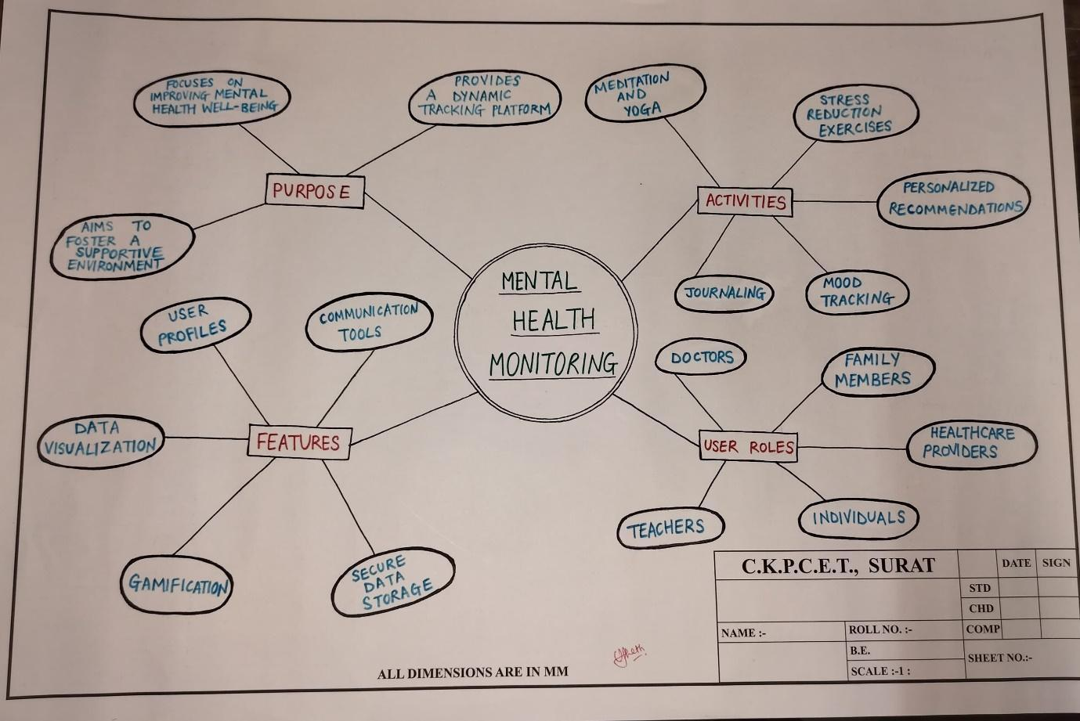
Fig 2.2.2 Mind Mapping

The above image shows a mind map of our project. As shown in the figure, we have various features in our project like user profiles, communication tools, data visualization, secure data storage and gamification storage as well as different activities like meditation, yoga, stress reduction exercises, personalized recommendations, mood tracking, journaling and much more.

Empathy
Observations through Empathy Mapping Canvas:
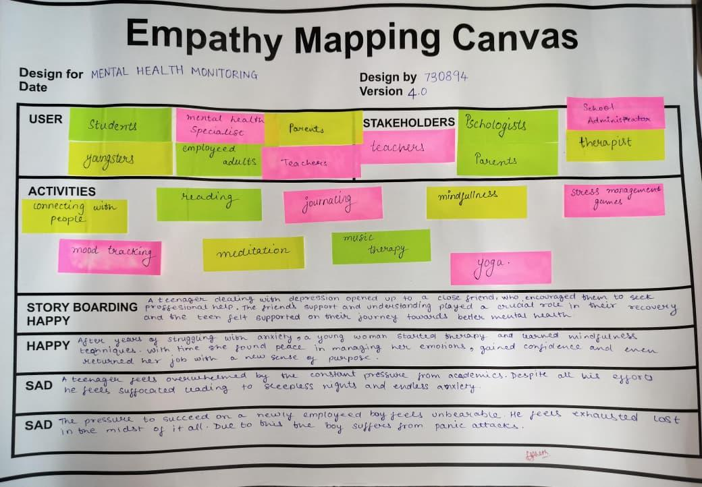
Fig 2.2.3 Empathy Mapping Canvas

In this canvas, we learned new things like stakeholders and storyboarding. Stakeholders are the people who are directly connected to the system. In storyboarding, we learnt what the happy or sad things are being observed by a user.

- User
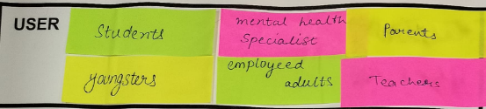
Fig 2.2.3.1 user
The users who are directly or indirectly connected to the system are listed below:
- Students
- Mental Health Specialist
- Youngsters
- Parents
- Teachers
- Adults
- Stakeholders
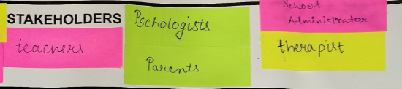
Fig 2.2.3.2 Stakeholders
Stakeholders are the people who are directly connected to the system. They are listed below:
- Teachers
- Psychologist
- Therapist
- Parents
- school administration

- Activities
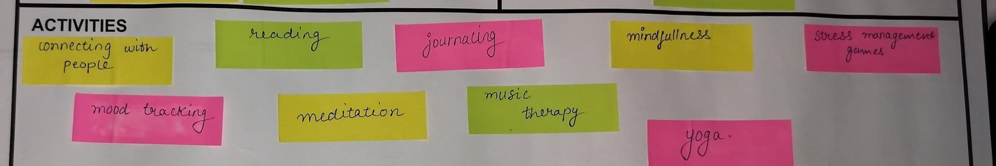
Fig 2.2.3.3 activity

The activities that are happening are listed below:
- Connecting with people
- Reading
- Journaling
- Mindfulness
- Stress management games
- Mood Tracking
- Meditation
- Music Therapy
- Yoga

4.Story Boarding
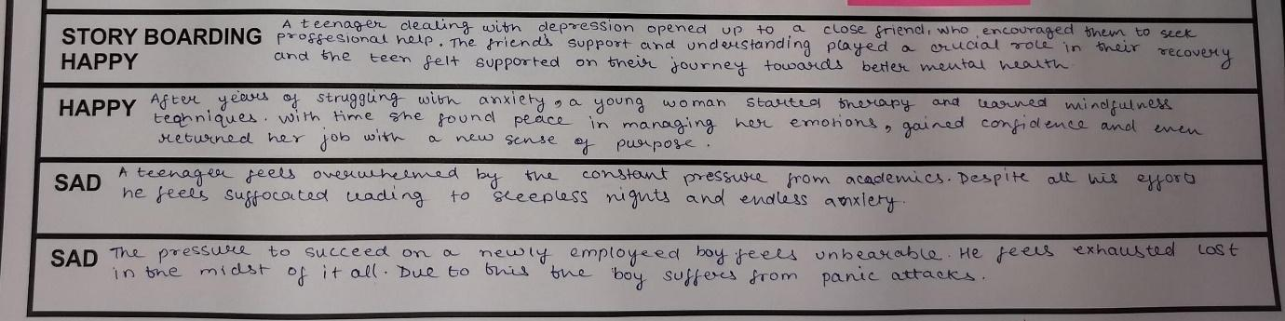
Fig 2.2.3.4 Story boarding

Following are the stories we have experienced during the survey:
- Happy
- A teenager dealing with depression opened up to a close friend, who encouraged them to seek professional help. The friend’s support and understanding played a crucial role in their recovery and the teen felt supported on their journey towards better mental health.
- After years of struggling with anxiety, a young woman started therapy and learned mindfulness techniques with time she found peace in managing her emotions, gained confidence and even returned her job with a new sense of purpose.
- Sad
- A teenager feels overwhelmed by the constant pressure from academics. Despite all his efforts, he feels suffocated leading to sleepless nights and endless anxiety.
- The pressure to succeed on a newly employed boy feels unbearable. He feels exhausted and lost in the midst of all of it. Due to this, the boy suffers from panic attack

Ideation

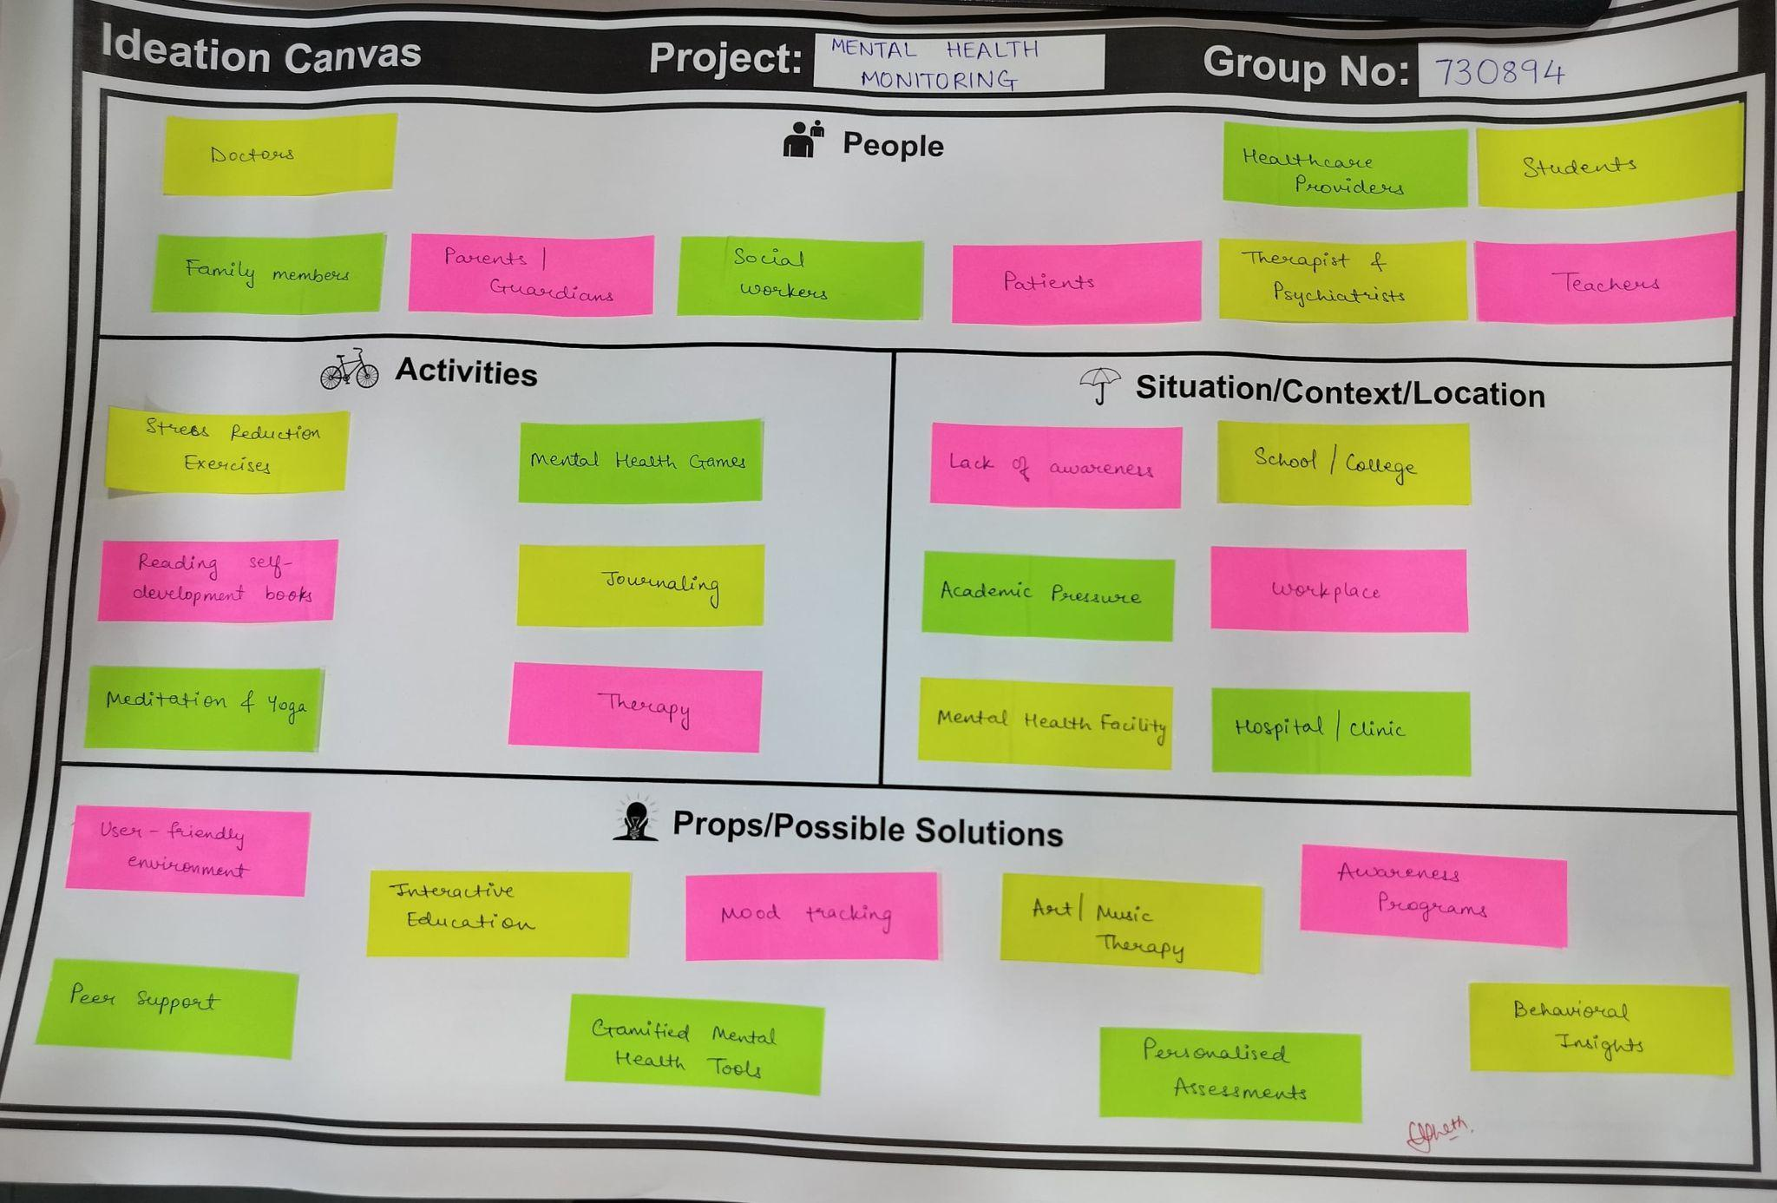
Fig:2.2.4 ideation canvas
- People
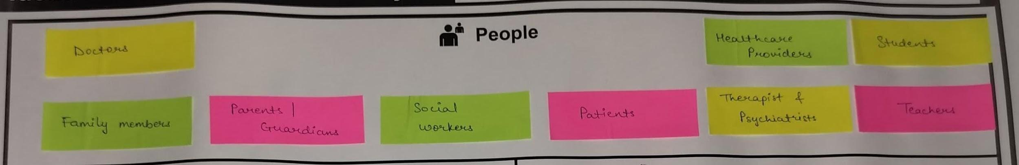
Fig:2.2.4.1 people
Generally, people who are connected with the system are as follows:
- Doctors
- Family members
- Parents / Guardians
- Social Workers
- Patients
- Healthcare providers
- Therapists and Psychiatrists
- Students
- Teachers.

- Activities
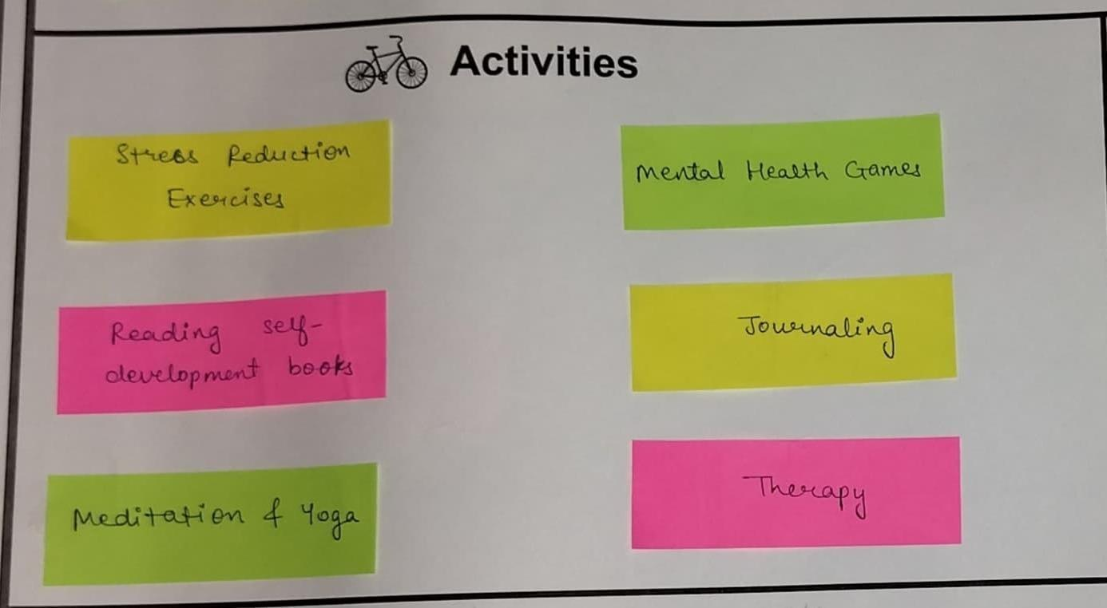
Fig:2.2.4.2 activity
The following list shows the activities noticed during the survey:
- Stress reduction exercises
- Reading self-development books
- Meditation and Yoga
- Mental Health games
- Journaling
- Therapy
- Situation / Context / Location
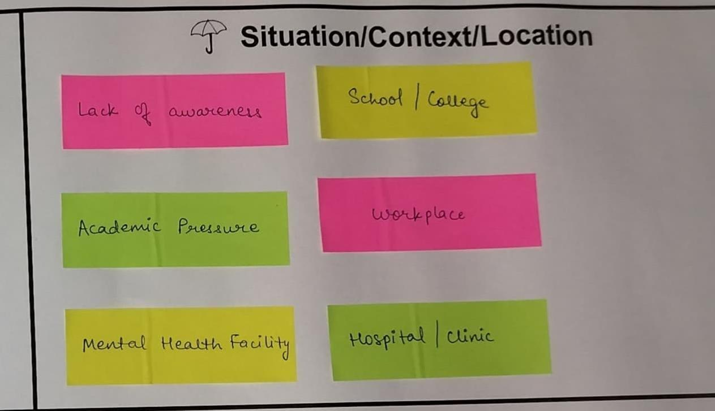
Fig:2.2.4.3 Situation / Context / Location
These are the list of problems that we have observed during the survey:
- Lack of awareness among people
- Academic Pressure at the Workplace
- Mental health facilities at Hospitals

- Props / Possible Solutions
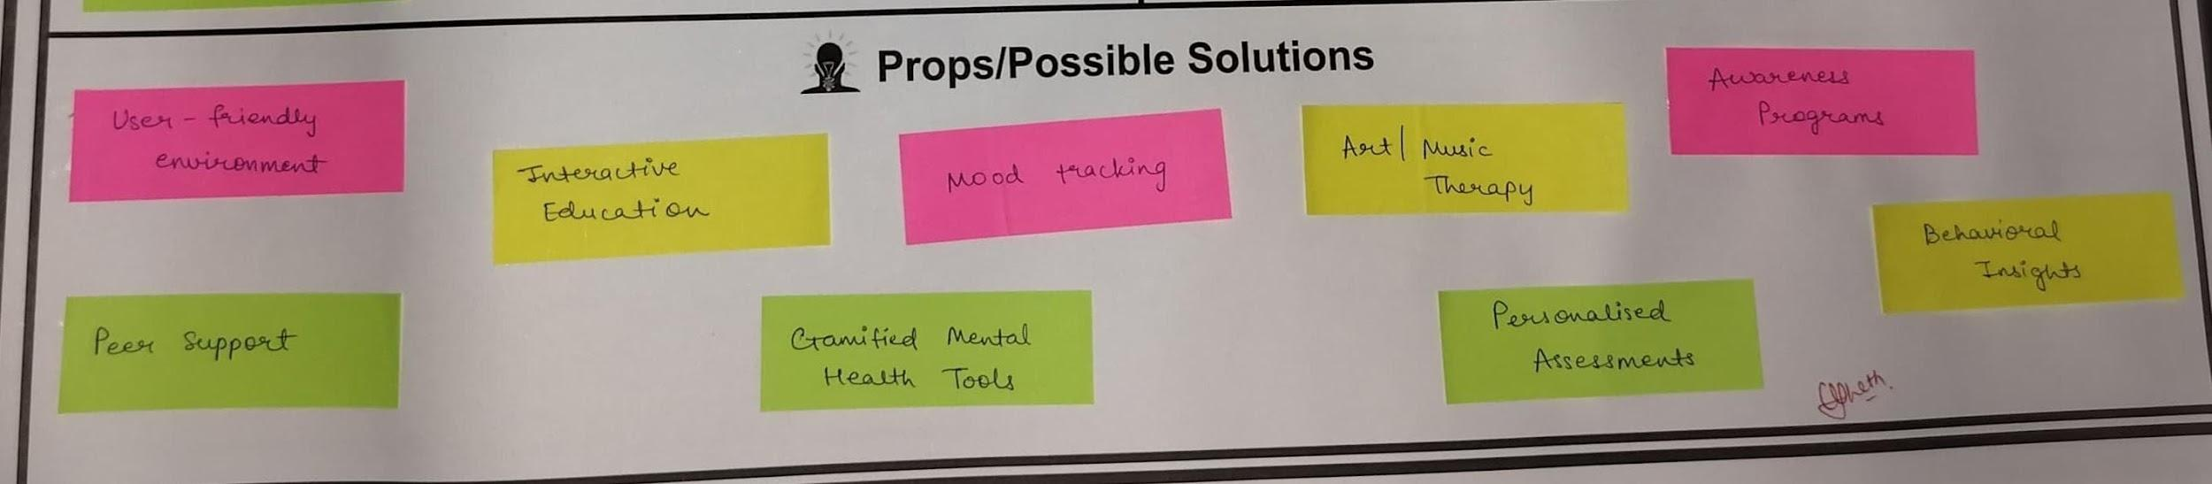
Fig:2.2.4.4 Props / Possible Solutions
The possible solutions that we think to implement to solve the above problems are listed below:
- User-friendly environment
- Peer support
- Interactive Education
- Mood tracking
- Gamified mental health tools
- Art / Music therapy
- Personalised assessments
- Awareness programs
- Behavioural insights

Product Development
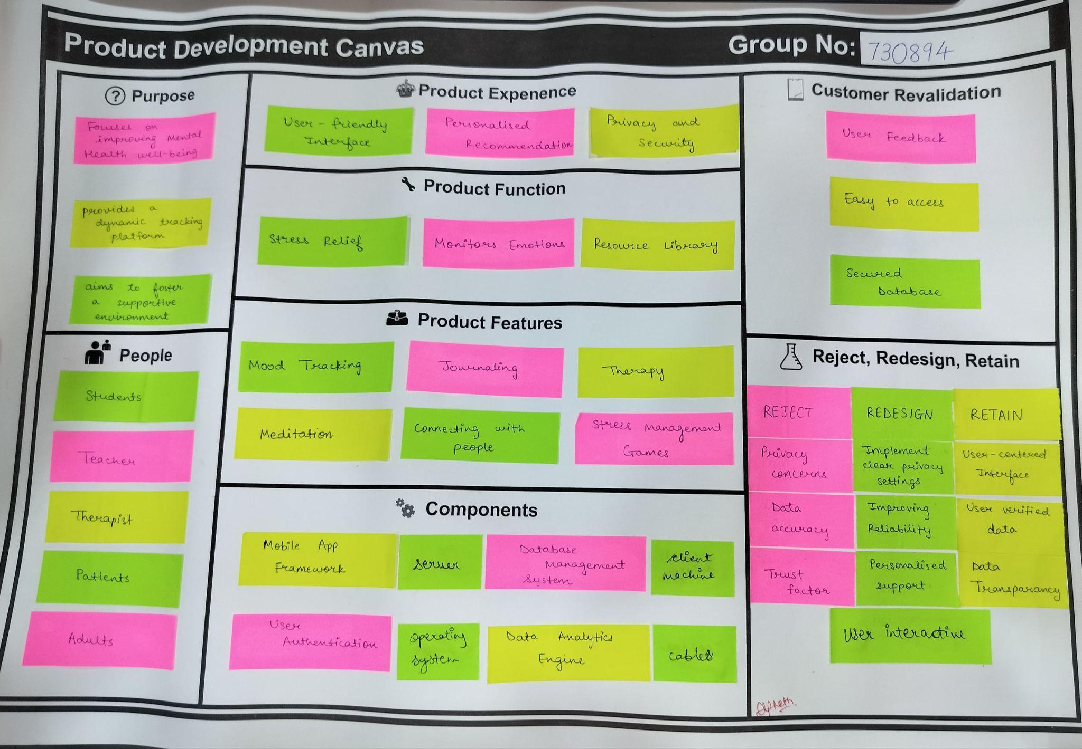Fig:2.2.5 product development
In this canvas, we have learned about how to plan our product on the canvas. We have written about our product experience, product features, product functions as well as customer revalidation. In the reject, redesign and retain part, we shared our ideas for the product with some people and we had to write what they think about our product.

    - Purpose
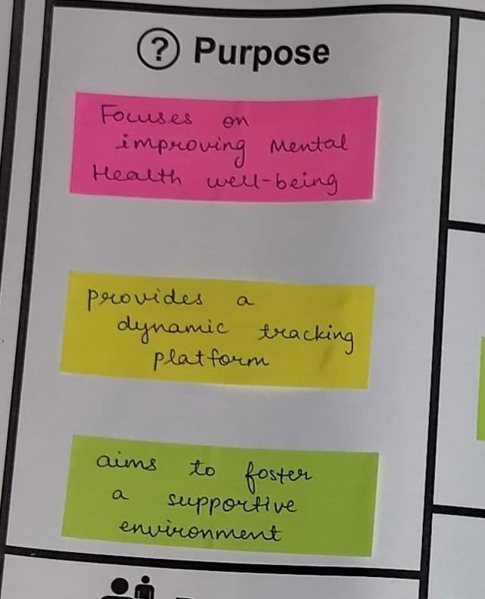
Fig:2.2.5.1 purpose
The main purpose behind this project are listed below:
- Improving mental health and well-being
- Providing a dynamic tracking platform
- Fostering a supportive environment

    - People
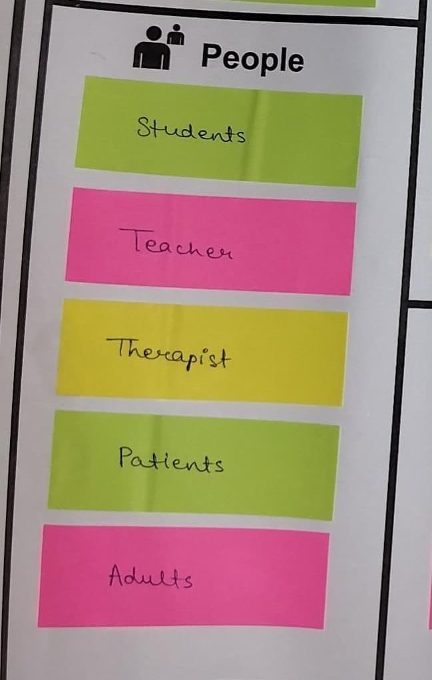
Fig:2.2.5.2 people

Following is the list of people:
- Students
- Teachers
- Therapist
- Patients
- Adults

    - Product Function
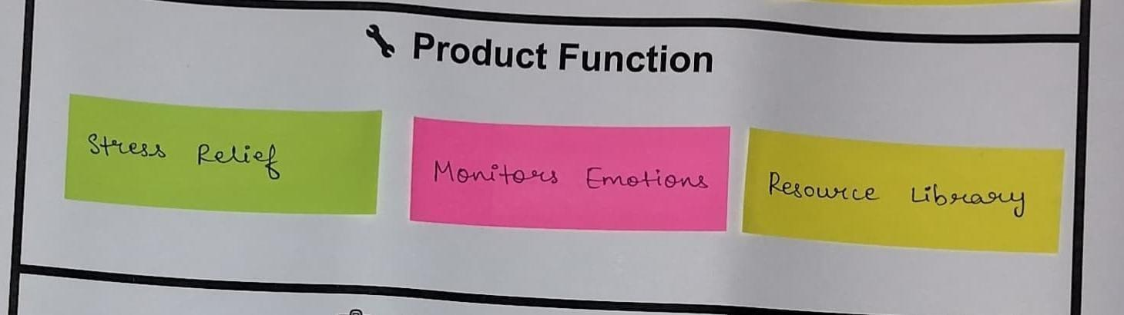
Fig:2.2.5.3 product function
The following list shows the function of the application:
- Stress relief
- Monitors emotions
- Resource Library

    - Product Features
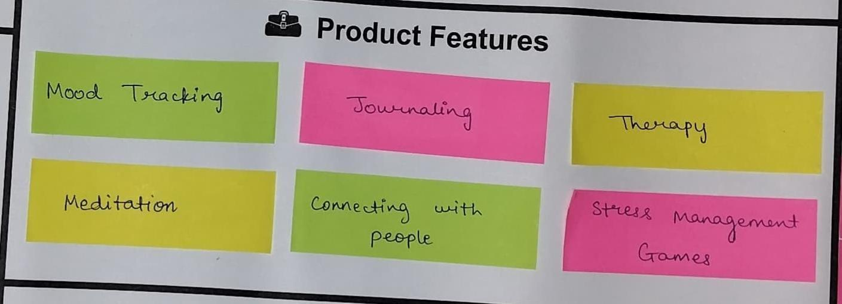
Fig:2.2.5.4 product features
Following is the list of features in our application:
- Mood tracking
- Journaling
- Therapy
- Meditation
- Connecting with people
- Stress management games

    - Product Experience
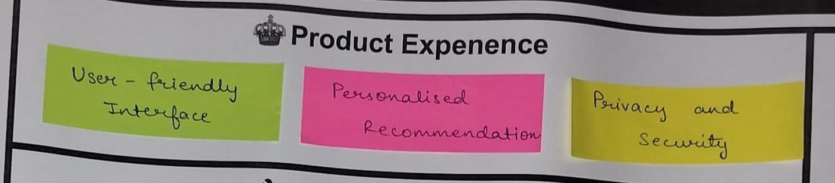
Fig:2.2.5.5 product expense
The list shows what might be the product experience of our application.
- User-friendly interface
- Personalised recommendation
- Privacy and security

    - Components
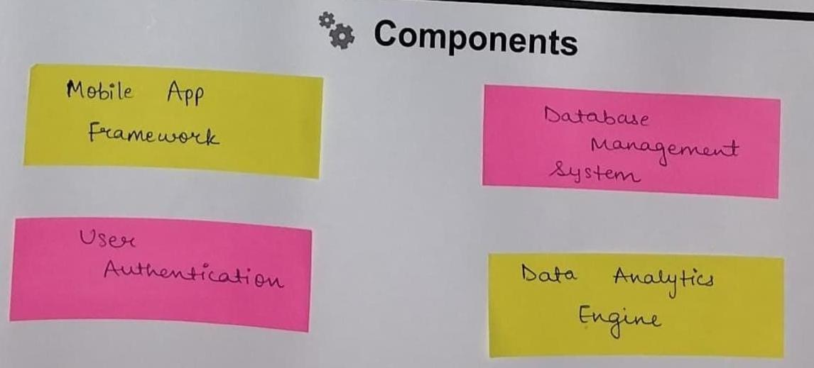
Fig:2.2.5.6 components
For our application, the components required are as follows:
- Mobile app frameworks
- Database management system
- User authentication
- Data analytics engine

    - Customer Revalidation
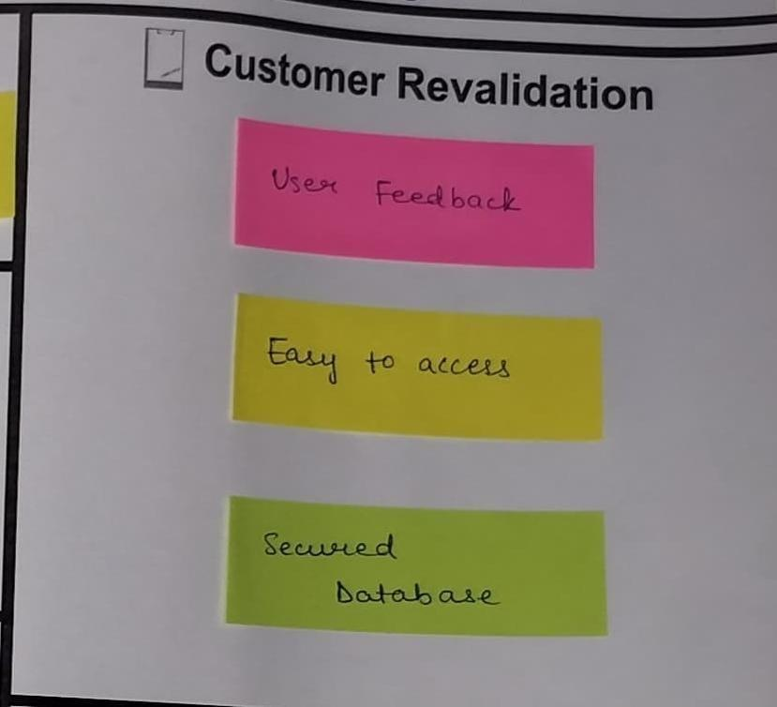
Fig:2.2.5.7 customer revalidation
Following are the feedback we received from people:
- User Feedback
- Easy to access
- Secured database

    - Reject, Redesign, Retain
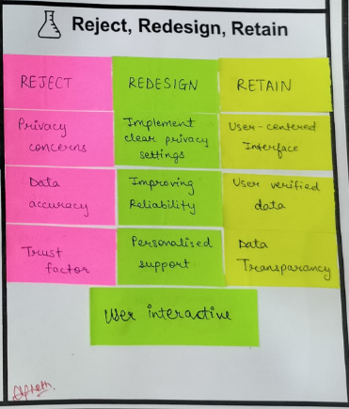
Fig:2.2.5.8 Reject, Redesign, Retain
This section tells us about the changes that we can do to make our app better:
Reject:
- Privacy concerns
- Data Accuracy
- Trust factor

Redesign:
- Implement clear privacy settings
- Improving reliability
- Personalised support

Retain:
- User-centered interface
- User verified data
- Data transparency

Feedback Analysis

A detailed description of Customer revalidation part from Product Development Canvas:
Positive Feedback:
- Simplicity of Navigation: The intuitive user flow—from logging mood to accessing recommendations—made the app approachable even for first-time users or those unfamiliar with digital wellness tools.
- User-Friendly Design: Customers appreciated the simple, calming interface, reporting that the pastel colours and intuitive navigation reduced the feeling of overwhelm.
- Tracking Tools: Users highlighted the value of tracking tools for mood and stress patterns, noting that they felt more in control of monitoring their mental health over time.
- Resource Library: Users found the self-help resources practical, especially the guided exercises for mindfulness and stress relief, which made the app feel supportive.
Negative Feedback/Suggested Improvements:
- Customization Options: Some users suggested adding more options for customizing the tracking tool, such as setting personalized goals or adding notes to log specific emotions.
- Limited Crisis Support Features: Some users pointed out that the app lacked critical features like an SOS button or instant connection to mental health helplines, which could be life-saving for users in acute distress.
- Reminder Settings: Customers expressed the need for customizable reminders to encourage daily use without feeling pressured.
- Privacy Concerns: Some participants voiced concerns about data privacy, suggesting clearer information on data security measures and an option to export personal data securely.

Prior Art Search

Secondary Research
After the observation phase, a secondary research analysis was conducted to review existing mental health monitoring tools, platforms, and academic literature on mental health technology. The research focused on examining two relevant resources per team member to gather insights into current approaches and challenges in mental health monitoring. Here is a summary of the findings:
4.1 Mental Health Apps and Their Role in Early Intervention (Article Summary):
In recent years, mental health apps have become a valuable tool for early prevention, offering mental support for individuals who may be experiencing mild to moderate challenges. Research indicates that these apps, which provide space and features like Cognitive Behavioural Therapy (CBT), mood tracking, meditation, and journaling, play a significant role in helping users manage symptoms before they escalate. For our project, we examined popular mental health apps such as Woebot, Headspace, and Moodfit, which have been highly regarded for their approach to early mental health intervention.
4.2 Video Analysis: The Future of Mental Health Care with AI and Digital Platforms:
A TED Talk discussed the potential of AI in transforming mental health care by offering scalable, data-driven support that can adapt to users’ unique needs. The speaker emphasized the potential for digital platforms to reduce the burden on healthcare systems by offering preliminary support and self-help tools. The talk also highlighted privacy and ethical concerns, emphasizing the need for secure data handling in mental health applications.
Insights for the Project: The potential for AI-driven support resonated with our project’s goal of creating a responsive mental health app. Consequently, we prioritized designing adaptive assessment tools that adjust based on user feedback and mental health trends. We also emphasized strict data privacy measures to build user trust.
4.3 Article Summary: Socio-Economic Impact of Mental Health Monitoring in Digital Health:
This research article examined the socio-economic impacts of widespread mental health monitoring. It discussed how digital tools reduce stigma by providing accessible support, thus potentially lowering healthcare costs by preventing serious mental health issues. Additionally, the study emphasized the importance of socio-economic inclusivity, as many individuals may not seek in-person therapy due to financial or social barriers.
Insights for the Project: The findings reinforced the socio-economic importance of digital mental health tools, inspiring us to ensure our app’s accessibility and affordability. By focusing on user-friendly and scalable solutions, our project aims to reach a broad demographic, promoting early mental health intervention across different socio-economic groups.
4.4 Case Study: Tracking Mental Health Trends Using Wearable Technology (Magazine Article Summary):
A magazine article discussed how wearable devices are increasingly being used to monitor physiological indicators related to mental health, such as heart rate variability and sleep patterns. These indicators provide real-time feedback and enable predictive analysis, allowing users to recognize and address early signs of stress or anxiety.
Insights for the Project: This case study informed our decision to incorporate user-friendly tracking features within our app, which can monitor mental health indicators through daily assessments and self-reporting tools. The potential for future integration with wearable devices was also considered for expanding the app’s functionality in monitoring physical indicators related to mental well-being.

These findings provided a strong foundation for the project, shaping our approach to user engagement, data privacy, accessibility, and the potential for advanced monitoring features. The research highlighted both the potential and challenges of digital mental health solutions, enabling us to design a supportive, data-driven application that addresses real-world needs in mental health monitoring

Functional Prototype

This semester, we completed the full-stack implementation of MindTrack, a mental health monitoring web application. The platform is built on Next.js 14 with TypeScript, backed by a Prisma ORM layer over SQLite, and integrates the Google Gemini API for AI-driven personalization. The interface uses a purple-gradient design system with glassmorphic cards, implemented in Tailwind CSS. Each page below reflects the deployed, functional state of the application.

Below is the detailed explanation of each interface:

5.1 Login Page
The Login Page is the entry point for returning users. Authentication is handled by NextAuth.js using session-based and JWT flows. Credentials are verified against bcrypt hashed passwords stored via Prisma.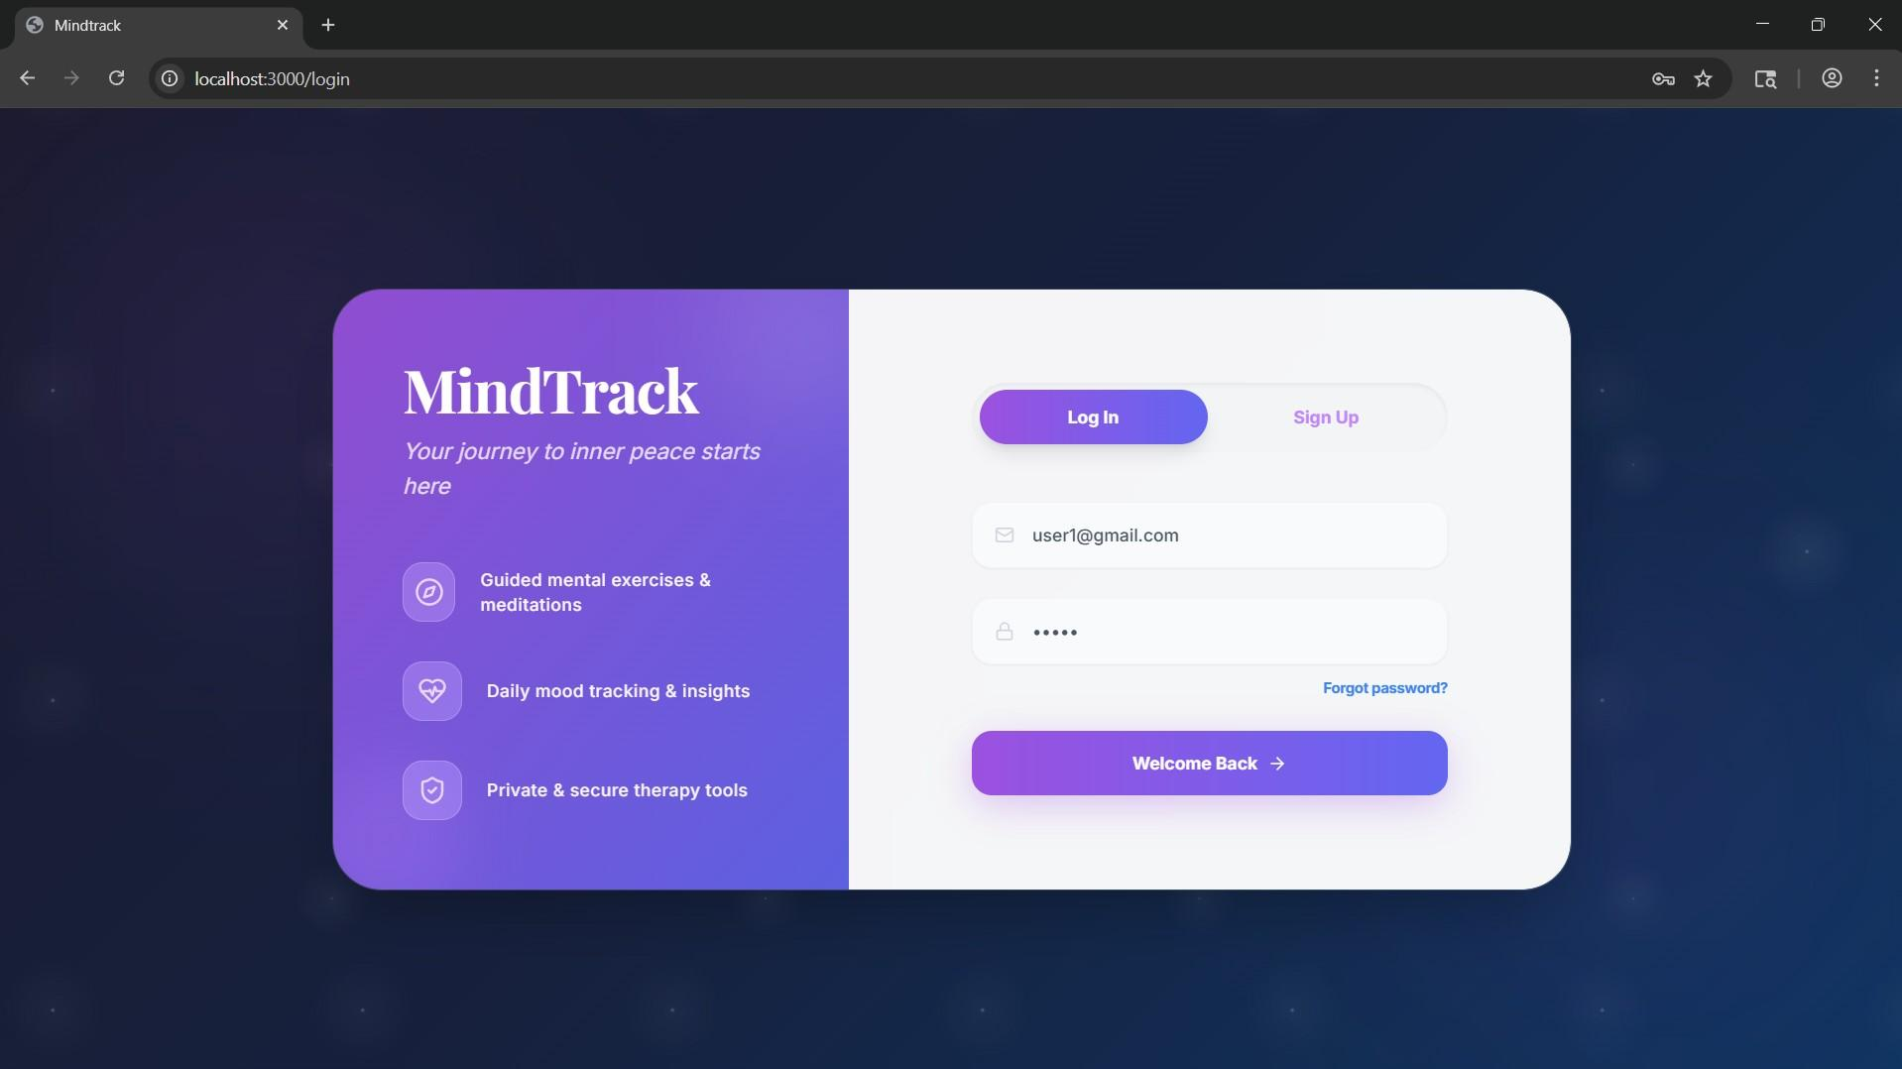

5.2: Sign Up Page
The Sign Up Page collects a username, email address, and password. On submission the register route hashes the password with bcrypt, creates a User record via Prisma, and redirects to the login screen.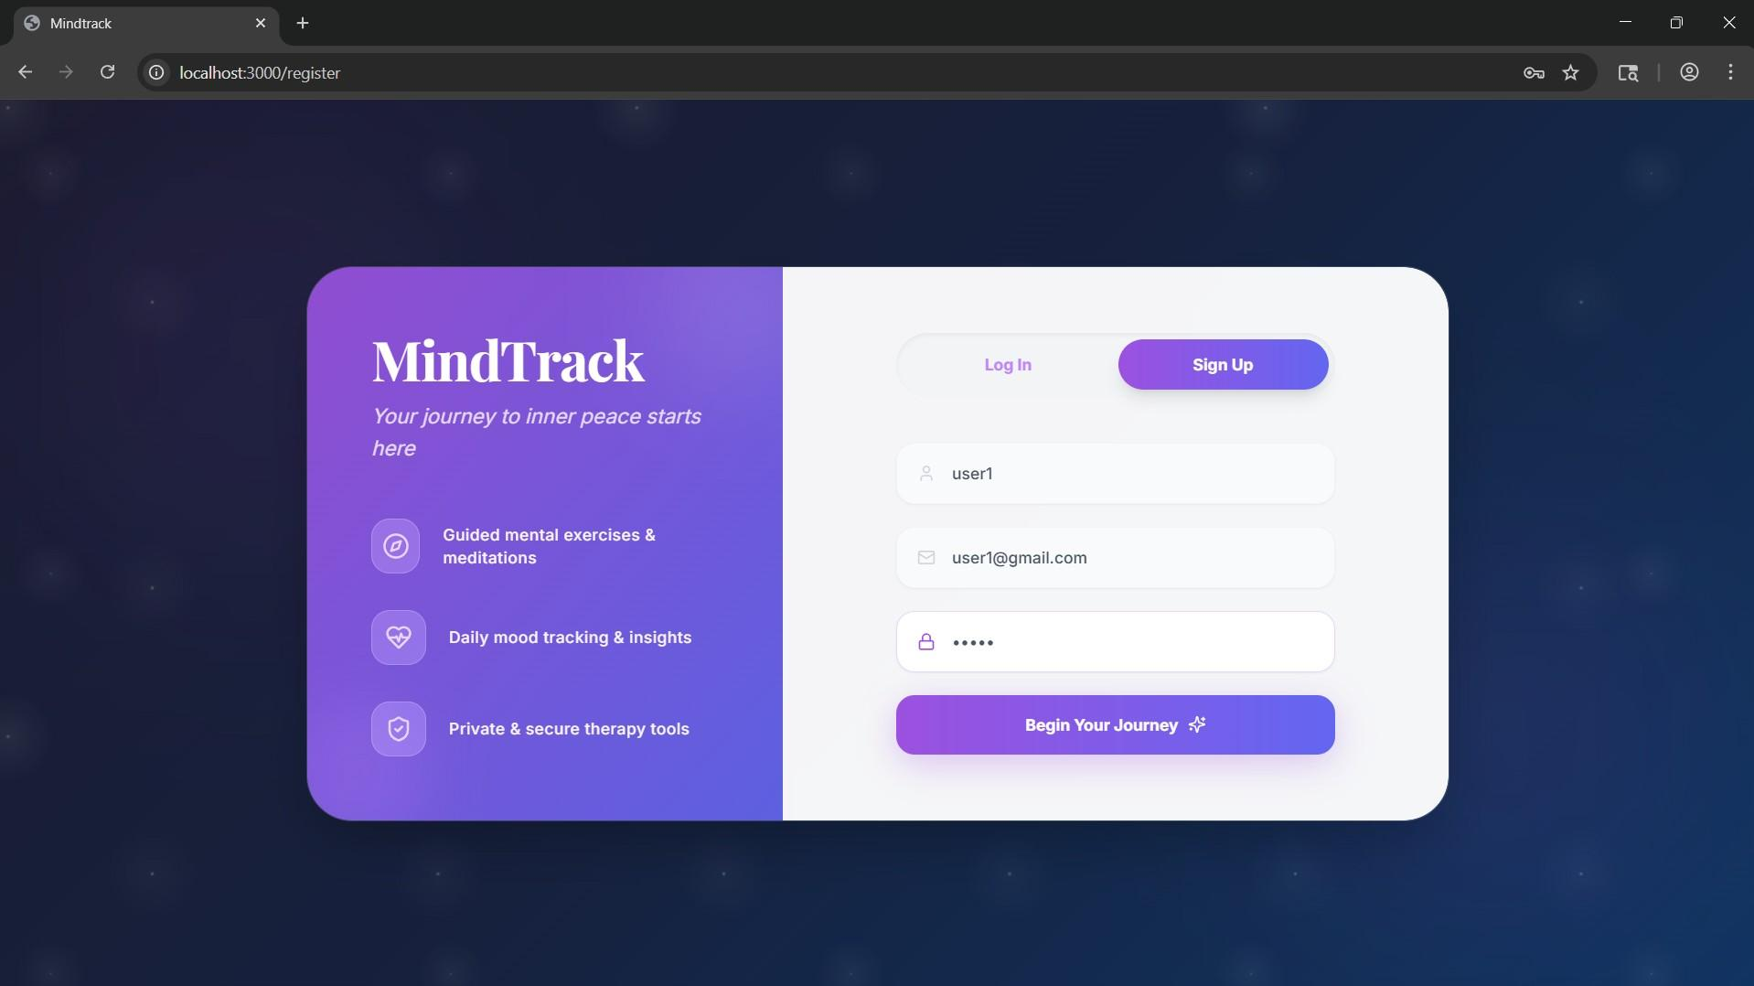

5.3: Mood Tracker
The Mood Tracker lets users log their current emotional state using a slider ranging from Awful to Amazing. The selected mood renders a corresponding emoji. Users can attach quick tags (Work, Sleep, Health, Social, Exams, Family, Finances) and add a text note or use voice input. On submission, the entry is stored in the Mood table via Prisma, linked to the authenticated user. A streak counter and XP bar reinforce daily use.
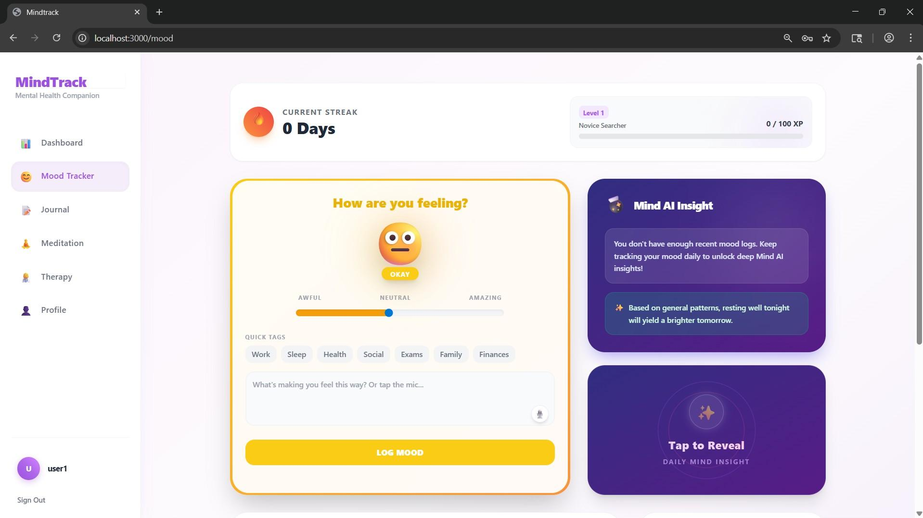

5.4: Journal
The Journal Page is PIN-protected. On first access, the user sets a 4-digit vault PIN stored in the User model. Subsequent visits require PIN entry before the journal opens. Entries are stored in the JournalEntry table. The Gemini API generates a prompt suggestion based on recent entries, and on save it produces an AI-summarized theme tag for the entry. The PIN can be updated from the Profile page.
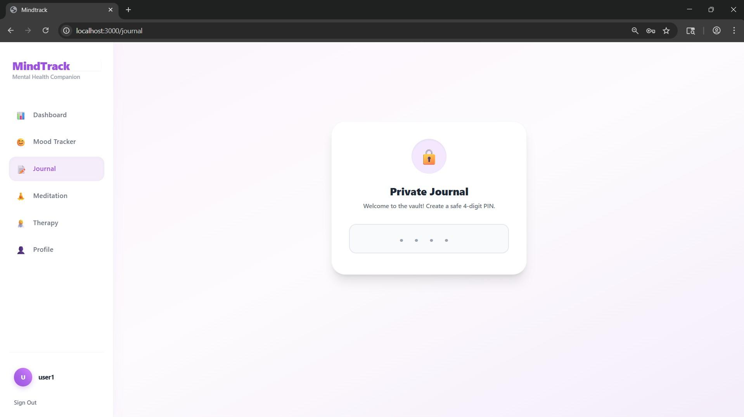

5.5: Meditation
The Meditation Page is a full meditation environment. Users choose a soundscape (Deep Space, Pine Forest, Ocean Waves, Soft Rain) and a breathing mode (Box 4-4-4-4, Deep Relax 4-7-8, or custom). An audio mixer lets them adjust Voice Guide, Environment, and Binaural Beats volumes independently. Quick Sessions offer preset durations: Stress Relief (5 min), Deep Sleep (20 min), Focus and Flow (10 min), and Anxiety SOS (3 min). When a session starts, the interface goes full-screen with an animated breathing circle and a countdown timer. Completed sessions are written to the MeditationSession table. Streak counts and total minutes are tracked for the Weekly Milestones card, and the AI Coach card unlocks after sufficient sessions.
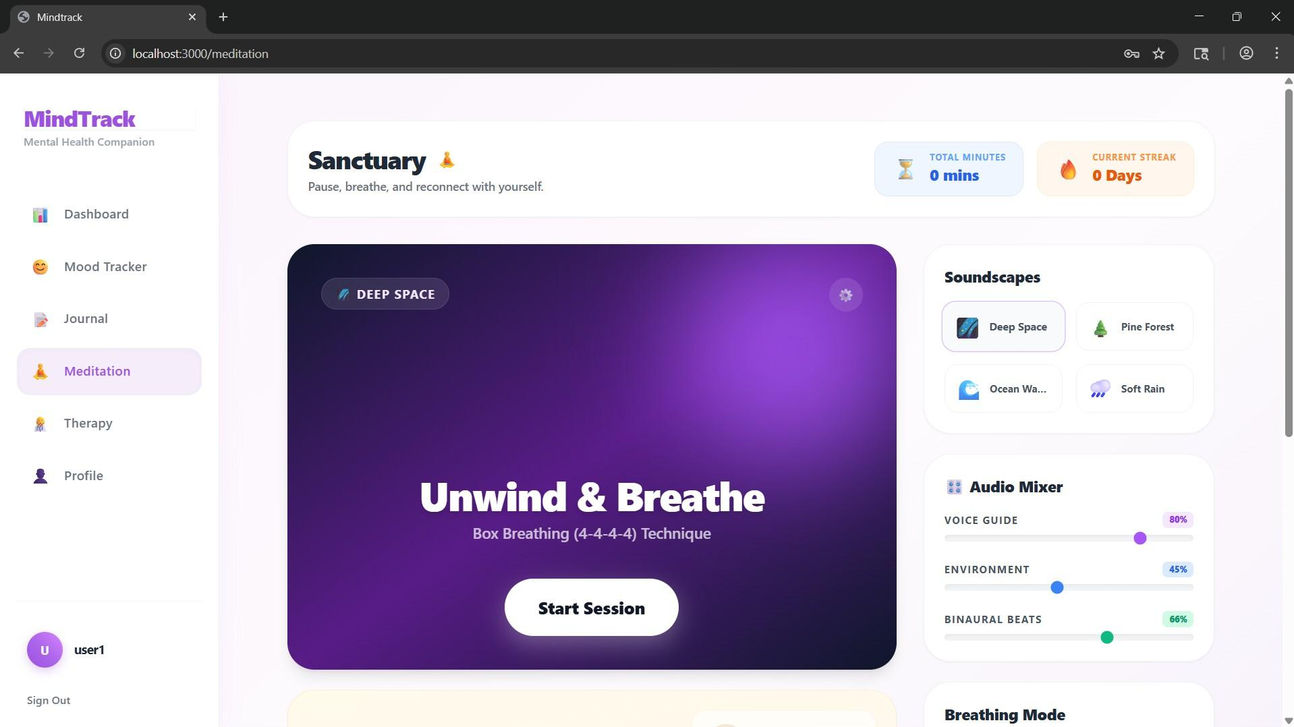
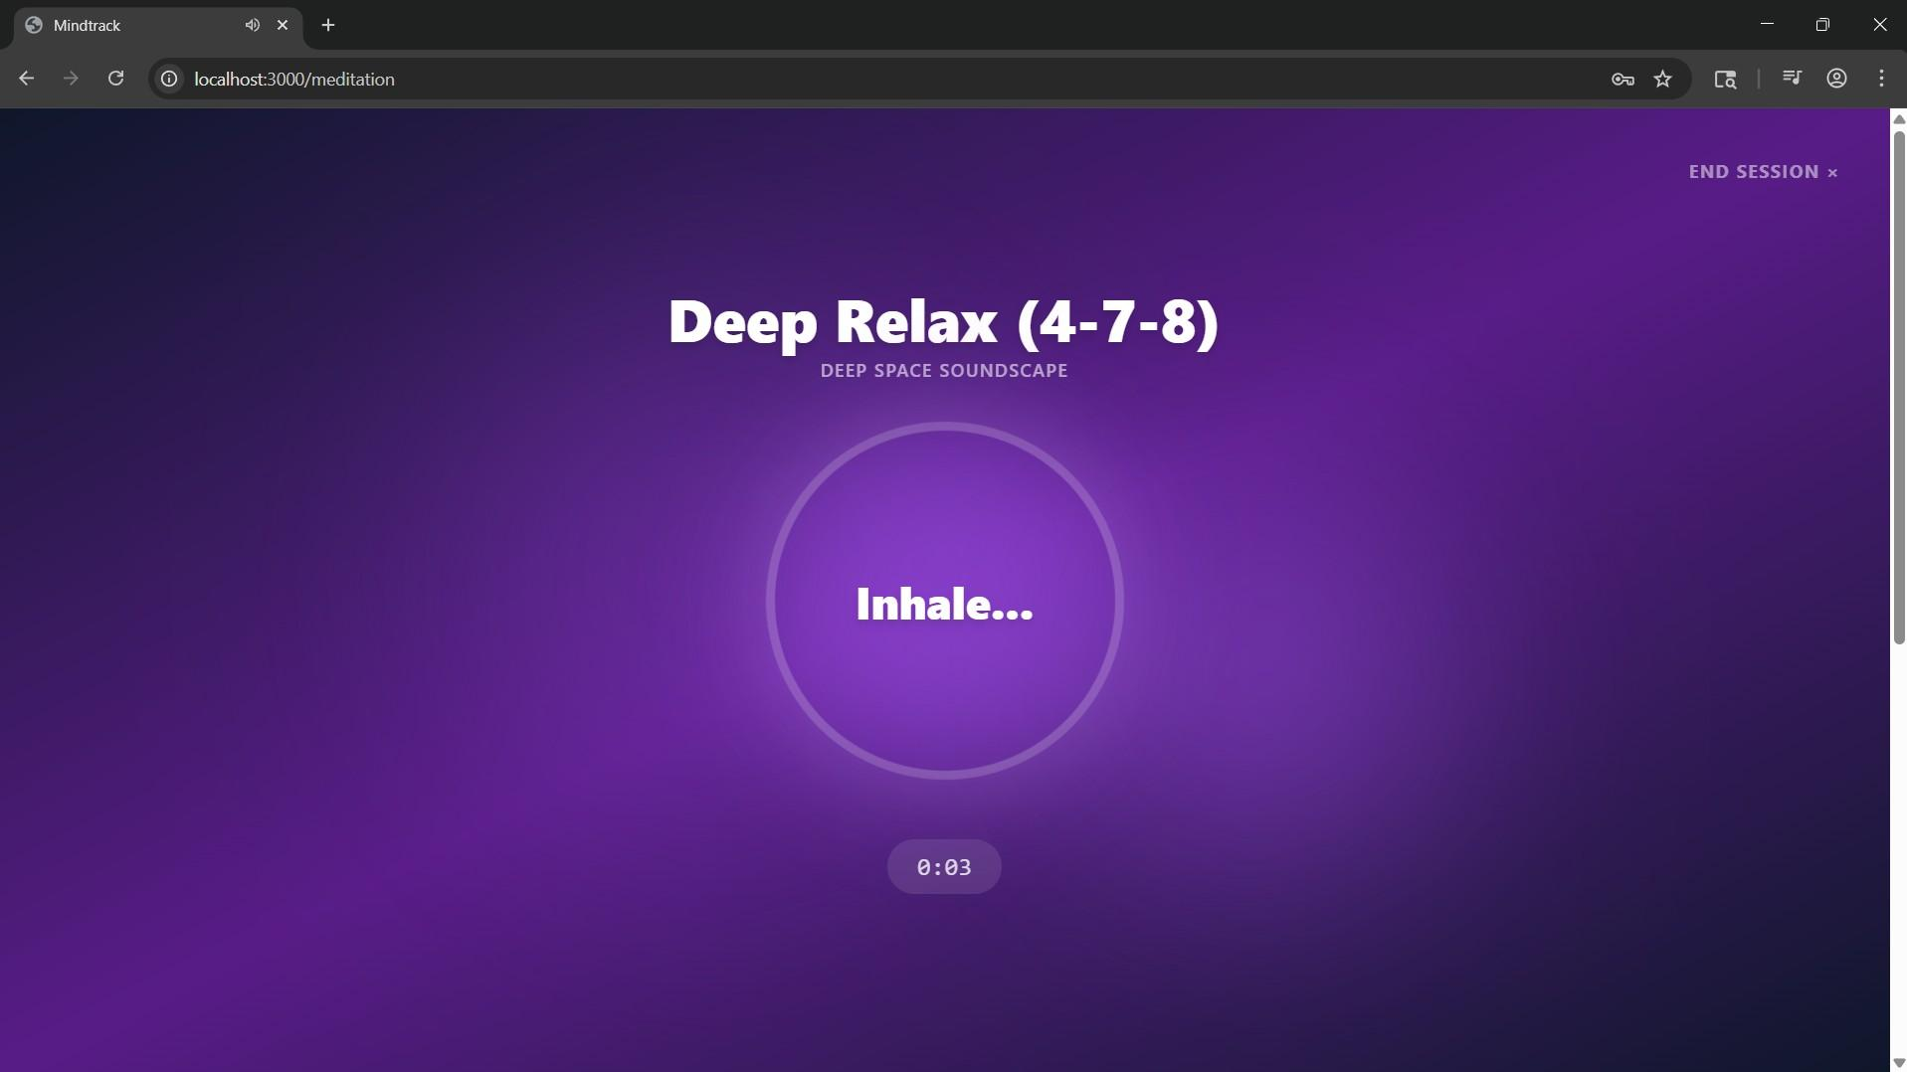

5.6: Therapy Management
The Therapy Management Page runs structured CBT-based modules. Each module has three steps: a symptom awareness checklist, a 5-question mini assessment with multiple-choice answers, and a completion screen. The content for all modules is defined statically in lib/therapyContent.ts. On completing the assessment, the answers are scored and a severity level is calculated server-side, then stored in the TherapyAssessment table. Users can proceed to journal their thoughts or return to the module hub.
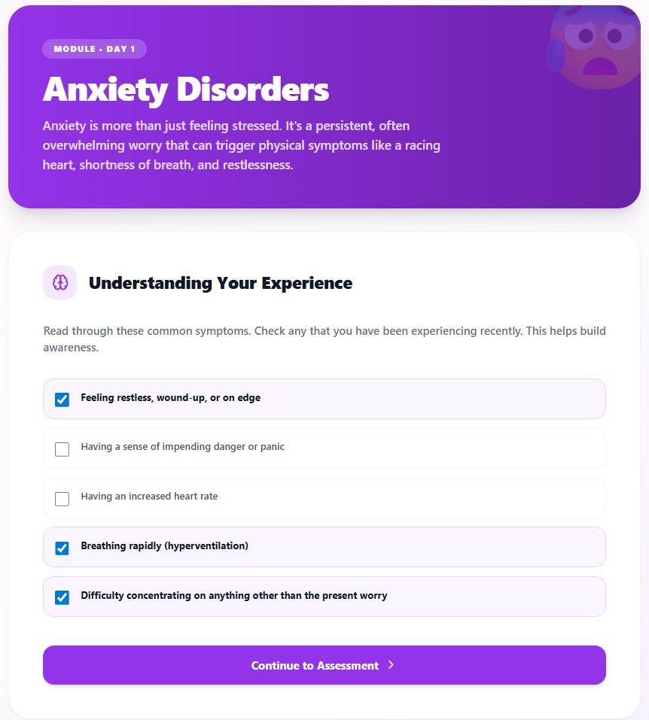
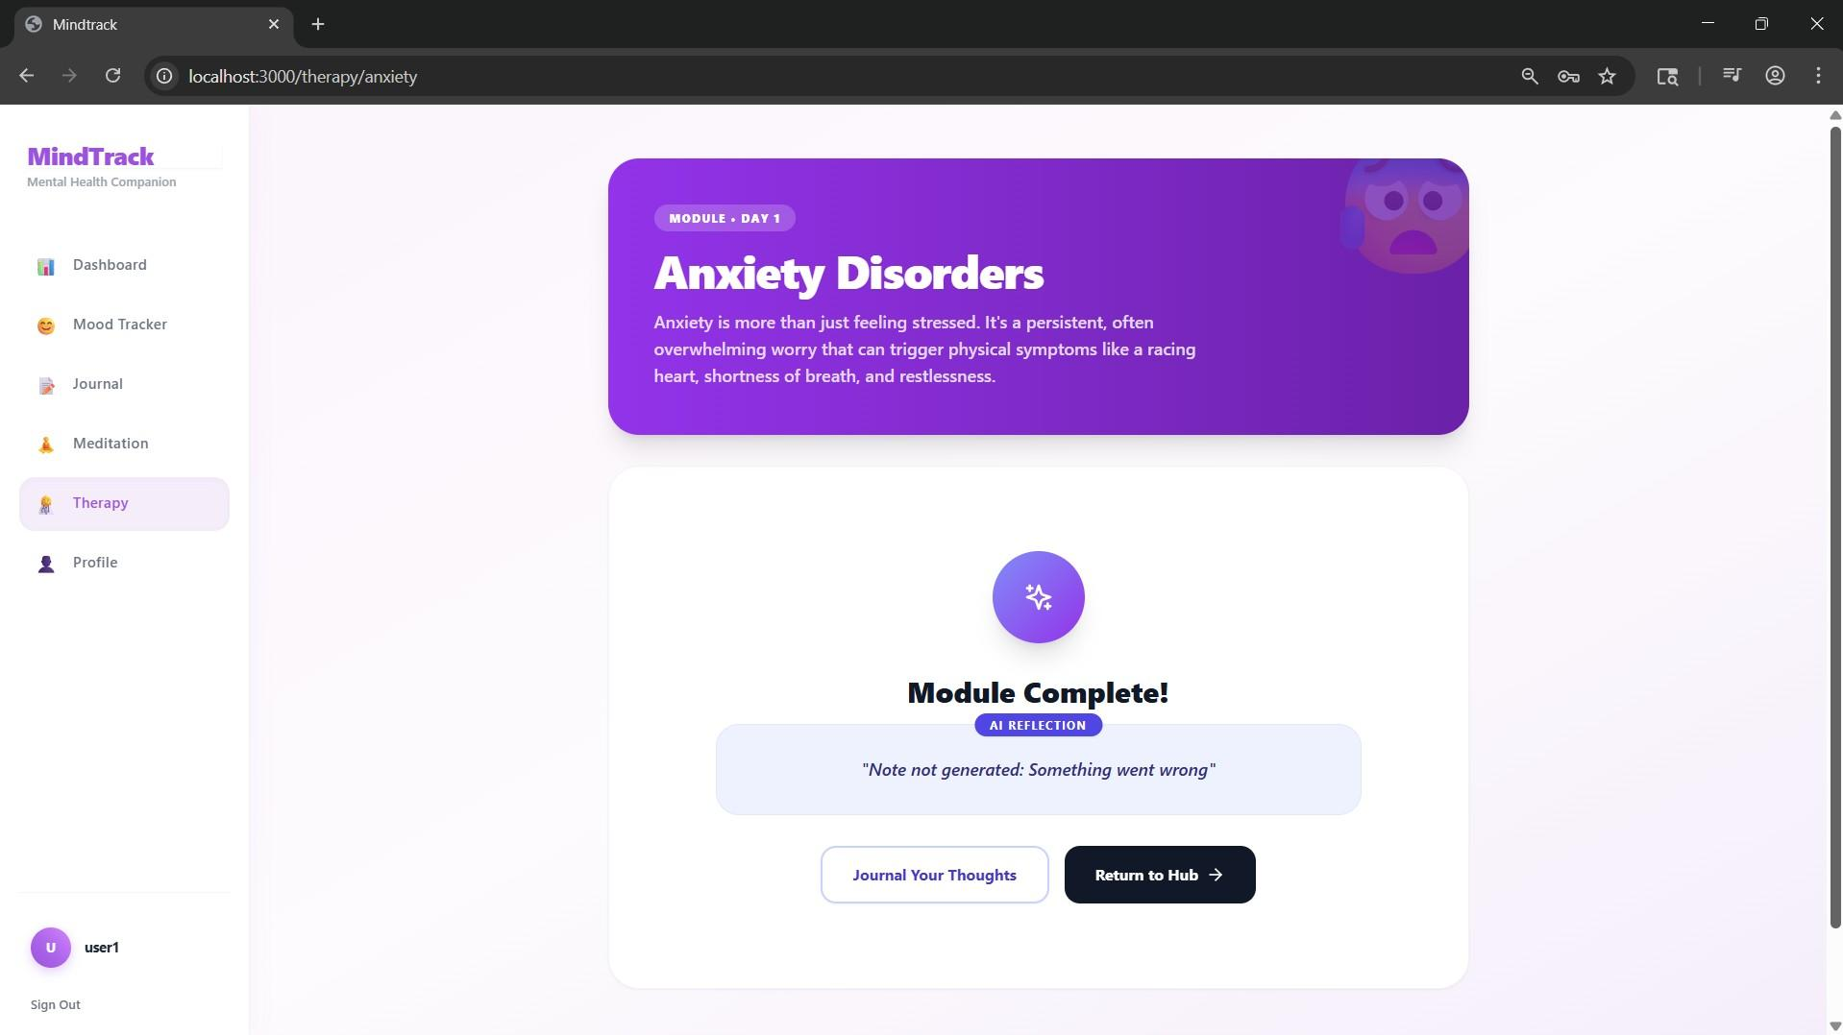

5.7: Dashboard
The Dashboard is the first screen after login. A purple gradient hero banner displays a welcome message and quick-access buttons for Meditation, AI Insights, and Therapy. Below it, three summary cards show the user’s current Mood Score, total Journal Entries, and Meditation Minutes, each pulling live data from analytics endpoint. Two feature cards link to Group Meditation and Clear Mind sessions. The layout is served as a Next.js server component with client-side hydration for the gamification state.
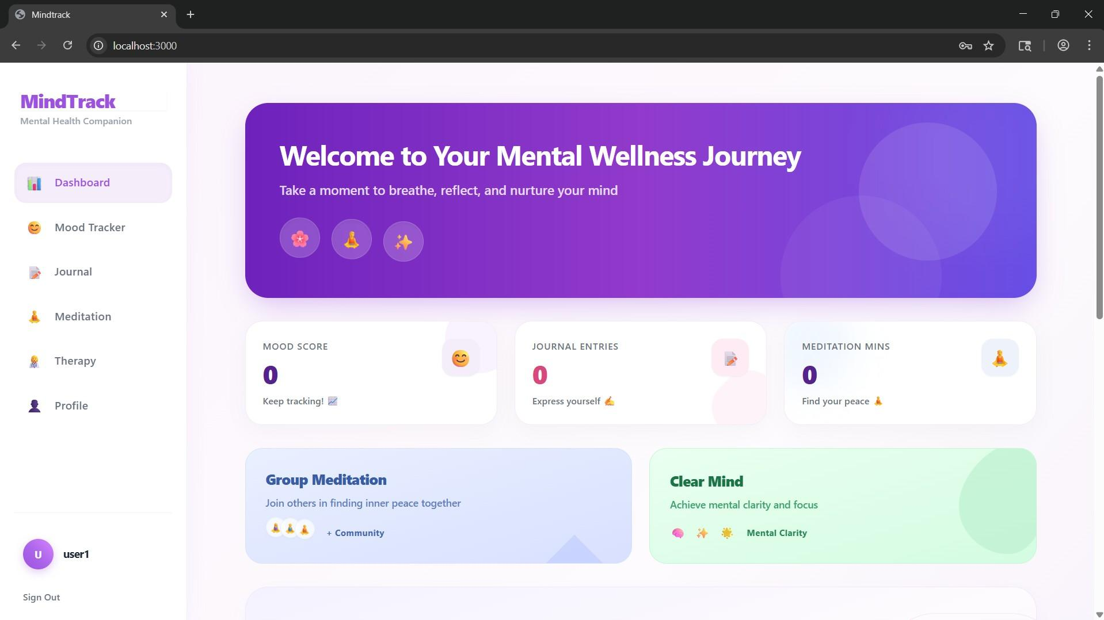

5.8: Profile
The Profile Page has two panels. The left panel allows the user to update their full name, phone number, email, account password, and Journal Vault PIN. Password changes are re-hashed with bcrypt before being saved via Prisma. The right panel displays Gamification and Stats: current day streak, total meditation sessions, average mood score, total meditation minutes, and journal entry count. These are computed server-side from the relevant tables and returned by /api/user/analytics.
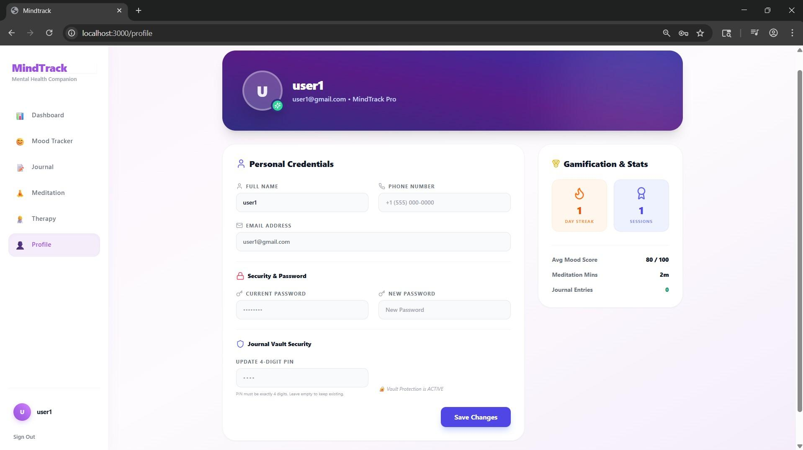

System Architecture, Technology Stack & Database Design

6.1 Technology Stack
We developed MindTrack using Next.js (App Router architecture) along with TypeScript to maintain strict type safety across the application. We designed the user interface using Tailwind CSS to keep the design clean, responsive, and consistent.
For the database, we used SQLite managed through Prisma ORM, which also helped us handle schema design and migrations efficiently. Authentication was implemented using NextAuth.js, where we supported both session-based and JWT-based login mechanisms.
We also integrated AI features using the Google Gemini API to generate personalized journaling prompts and therapy reflections. For data visualization, we used Chart.js along with react-chartjs-2 to display user insights in a clear way. Passwords are securely stored using bcrypt hashing, and we used a lightweight sentiment analysis library to process mood data before passing it to the AI system. For icons, we used Lucide-React to maintain a modern and consistent UI.

6.2 System Architecture
The application follows the Next.js App Router architecture. The root layout (app/layout.tsx) configures global fonts and wraps the application with provider components, including SessionProvider for authentication and a custom GamificationProvider for managing user progression. Pages are implemented as server components by default, while interactive features are handled using client components. Backend functionality is implemented through API routes under app/api/. A shared Prisma client instance is exported from lib/prisma.ts and utilized across server components and API routes to maintain consistency. Static therapy-related content, such as module text and resources, is stored in configuration files (lib/therapyContent.ts), reducing unnecessary database queries. Global state, such as user experience points (XP), is managed efficiently without requiring page reloads. The system is containerized using Docker, allowing easy scalability and migration from SQLite to PostgreSQL

6.3 Database Design
The database schema follows a relational model defined using Prisma ORM. The central entity is the User model, which stores authentication credentials, encrypted passwords, and gamification-related attributes such as experience points and levels. Additional models such as Account, Session, and VerificationToken support authentication workflows. All feature-related entities are associated with the User model through one-to-many relationships. These include Mood (emotional logs with intensity and timestamps), JournalEntry (user reflections with AI-generated insights), Habit (tracking routines and streaks), TherapyAssessment (evaluation scores and severity levels), TherapyJourney (progress tracking), Achievement (user rewards), and MeditationSession (mindfulness activity logs). Analytical operations are performed at the server level to generate aggregated insights, ensuring efficient data processing and optimized frontend rendering.

Semester VI Enhancements

7.1 Frontend improvements
In Semester V, our prototype was built using basic HTML and CSS. In Semester VI, we completely rebuilt the frontend using Next.js and TypeScript to make the application more scalable and structured.
We redesigned the UI using Tailwind CSS and introduced a consistent color theme with purple gradients and glassmorphic card components with backdrop blur effects. This made the interface feel more modern and aligned with the calming theme of the application.
We also improved interactivity across the app. We added animations to the meditation breathing circle, where it expands and contracts based on the breathing cycle, and made the mood emoji dynamic so it responds to the slider input. We implemented a persistent sidebar across all pages to improve navigation and make the user experience smoother.
We restructured the therapy module flow to make it more guided. Instead of showing everything at once, we designed it step by step, starting with a symptom checklist, followed by a short assessment, and ending with an AI-generated reflection. We also added features like a PIN protected journal for privacy and a profile page that shows live gamification stats like XP and levels.

7.2 Backend integration
In Semester V, the backend was planned using Python and Firebase but was not implemented. In Semester VI, a complete backend system was developed using Next.js API routes in combination with Prisma ORM.
Authentication was fully implemented using NextAuth, supporting secure email and password login along with session management. All core functionalities, including mood tracking, journaling, meditation sessions, therapy assessments, and profile updates, are now handled through structured API routes connected to the database via Prisma.
AI based features are integrated through dedicated API routes that connect to the Google Gemini API. These endpoints generate personalized journal prompts based on recent entries, provide reflections after therapy module completion, and assist in expanding user-written reflections.
Additionally, the analytics endpoint processes user data such as mood trends, activity counts, and streaks. The processed data is returned in a structured format and used to power dashboard visualizations and user insights.

7.3 New features: analytics, personalization, and gamification
We introduced several new features in this semester, focusing on analytics, personalization, and gamification.
For analytics, user activity data such as mood trends, weekly averages, and session counts is processed on the server and visualized using Chart.js. A sentiment analysis library is used to preprocess mood entries and generate polarity scores, which enhances the quality of insights provided to the user.
Personalization features were also added. The system generates journal prompts based on recent user activity and provides reflective feedback after completing therapy modules. An AI-powered insight panel highlights patterns in user behavior once sufficient data has been collected.
Gamification was implemented to improve user engagement. Users earn experience points by logging moods, writing journal entries, and completing meditation sessions. These points contribute to level progression, which is displayed through progress indicators. Achievement badges are awarded for milestones such as consistent meditation, and activity streaks are calculated based on user engagement over time.

Summary

During this semester, our team transitioned from conceptual design to implementation, focusing on the front-end development of Mindtrack.
The core objective was to visualize how users will interact with the platform and to ensure that every interface aligns with the project’s empathetic purpose.
We achieved the following key milestones:
- Developed a full-stack web application (Next.js, TypeScript, Prisma, SQLite, NextAuth, Google Gemini API).
- Designed intuitive layouts for Login, Signup, Dashboard, Mood Tracker, Journal, Meditation, Therapy, and Profile pages.
- Maintained emotional consistency through color psychology and minimal design elements.
- Incorporated user feedback from last semester to simplify navigation and enhance readability.
- Prepared the groundwork for backend integration delivered using Next.js API routes and Prisma, with AI personalization via Google Gemini.
Semester VI moved MindTrack from a front-end prototype to a production-ready application. Authentication, database persistence, AI personalization, gamification, and analytics are all live. The codebase is containerized and ready for PostgreSQL migration. MindTrack now functions as a complete mental wellness platform that tracks emotions, guides users through therapeutic content, and adapts to individual patterns using AI.

7. References
- Mohr, D. C., Weingardt, K. R., Reddy, M., & Schueller, S. M. (2017).
“Three problems with current digital mental health research... and three things we can do about it.” Psychiatric Services, 68(5), 427–429.
This paper outlines common design and implementation flaws in digital mental health tools and suggests strategies for improvement, such as involving end-users in the development process.
- Andersson, G., & Titov, N. (2014). "Advantages and limitations of Internet-based interventions for common mental disorders." World Psychiatry, 13(1), 4-11.
This paper discusses the benefits and constraints of online mental health interventions, such as accessibility and effectiveness.
- "Decoding Depression: How AI is Revolutionizing Mental Health." TED Talk by Khayretdinova, Mariam. (https://www.youtube.com/watch?v=32YgTYMhT4o.)
- Bostock, S., & Crosswell, A. (2019). "User engagement with a digital mental health intervention: Data from multiple studies on Calm and Headspace."
This paper discusses effective design principles and user engagement strategies for mental health apps.
- "The Mind, Explained" (2019) - Netflix This documentary series with episodes on topics like anxiety and mindfulness, illustrating how the brain processes emotions and stress. It was a great reference for understanding the basis of features like CBT and mindfulness in mental health apps.
- Torous, J., Myrick, K. J., Rauseo-Ricupero, N., & Firth, J. (2020). "Digital Mental Health and COVID-19: Using Technology Today to Accelerate the Curve on Access and Quality Tomorrow." JMIR Mental Health, 7(3), e18848. This paper examines how AI-driven digital mental health platforms can extend access to evidence-based interventions, and discusses design principles for personalized assessment and engagement — directly relevant to MindTrack’s mood analytics, Gemini-powered reflections, and gamified retention features.

